HUB Team Lead Benchmark (Class Exercise) The following Team Lead Benchmark was created from the Superior Performance Attributes Position Worksheets completed by the TOS Training Class, April 2023.
Top Priorities in the Team Lead Role:
- Strong people skills, able to influence employees and clients- and gets results.
(Spends most time here, 5 days a week.)
- Strong technical knowledge in insurance and local business processes.
- Proactive problem solver.
- Supports and influences change.
- Ability to excel in a fast-paced environment.

Top TriMetrix Superior Performance Attributes (S.P.A.) in the Role:

Personal Skills: (‘Under the Hood’, ‘Horsepower’, Acumen)
- Results Orientation - The ability to identify actions necessary to complete tasks and obtain results.
- Leading Others - The ability to organize and motivate people to accomplish goals while creating a sense of order and direction.
- Developing Others - The ability to contribute to the growth and development of others.
- Self-starting Ability - The ability to initiate and sustain momentum without external stimulation.
- Influencing Others - The ability to personally affect others’ actions, decisions, opinions or thinking.
- Flexibility - The ability to readily modify, respond to and integrate change with minimal personal resistance.
- Accountability for Others - The ability to take responsibility for others' actions.
*** Personal Accountability - A measure of the capacity to be answerable for personal actions.
***Self-Management - The ability to prioritize and complete tasks to deliver desired outcomes within allotted time.
frame
Top Motivators/Drivers: (‘Gas in the Tank’, Drivers)
- Utilitarian/Economic: A drive for practical results.
- Social/Altruistic: A drive to be of service.
- Individualistic/Political: A drive to lead and inspire others.

Top Behaviors Five Days a Week: (‘How Job/Person Drive’, Communication Style)
- People Oriented - Build rapport with a wide range of individuals.
- Interaction - Adapt to various situations with ease.
- Versatile - Rapidly shift between tasks.

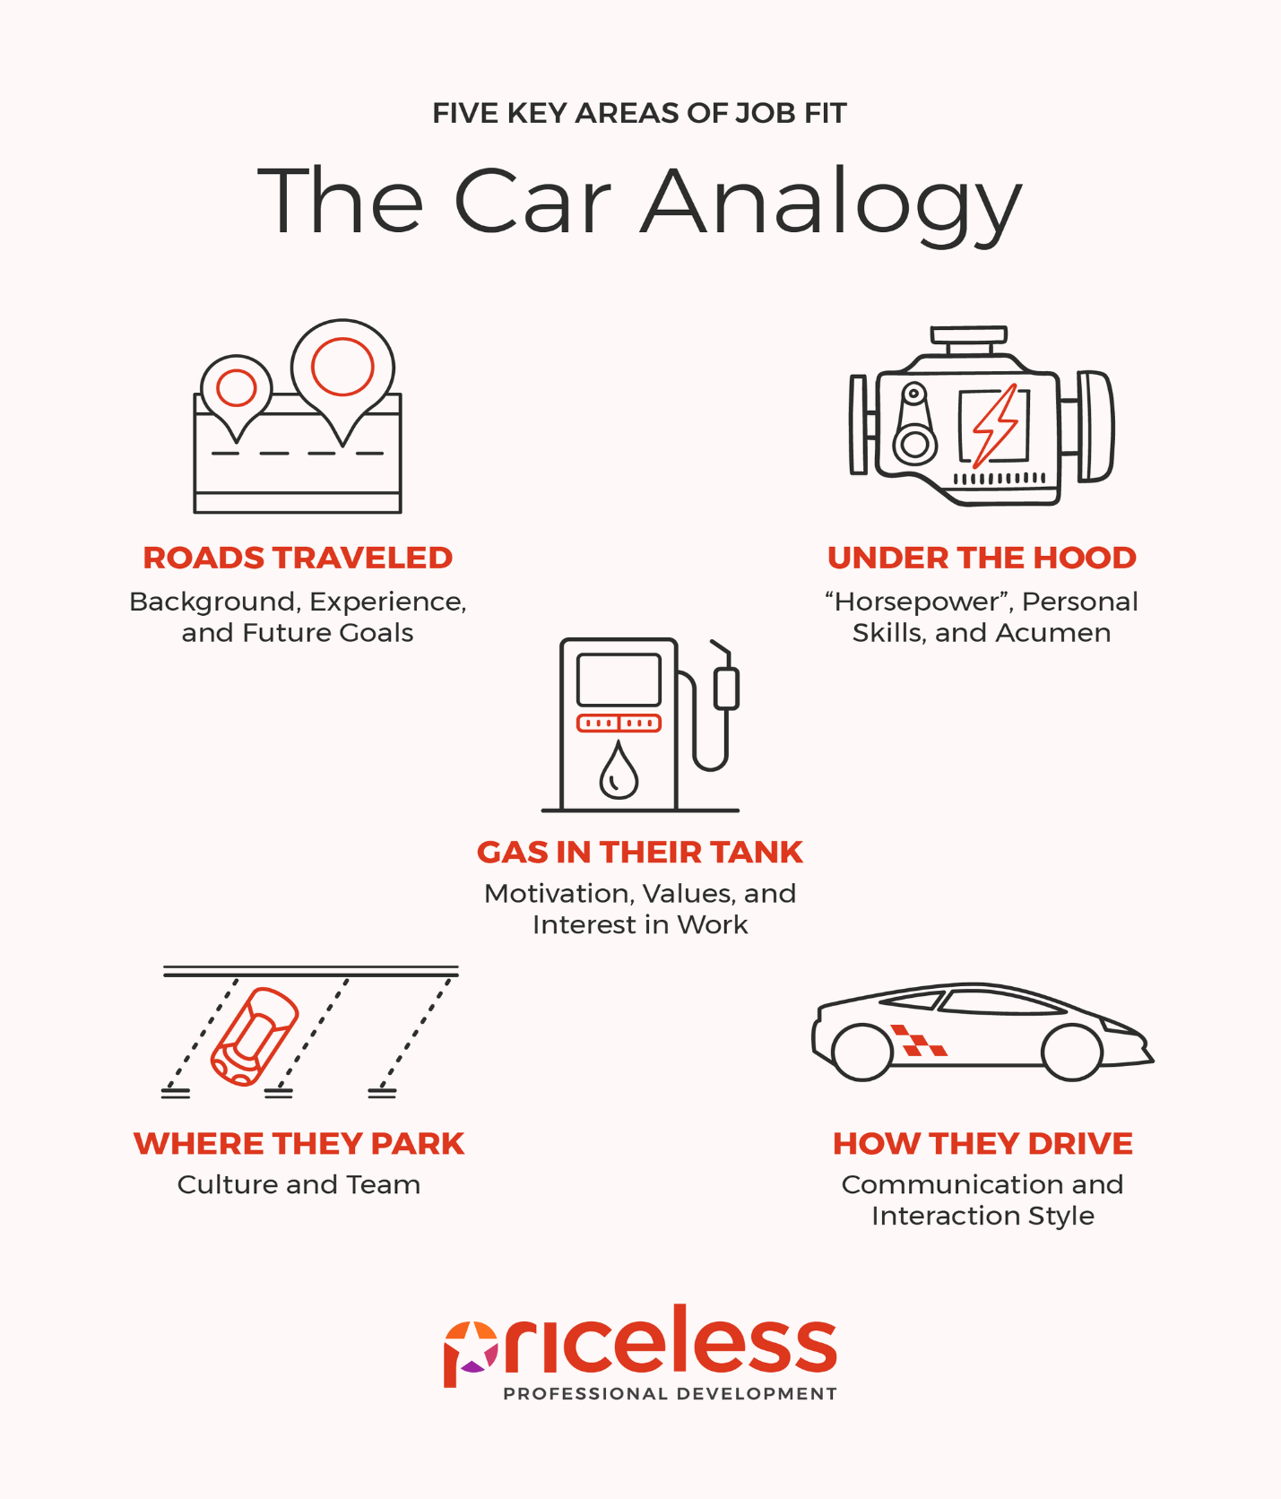
TriMetrix Measures Three Areas:
Under the Hood, Gas In-Tank and How They Drive.
The Assessment Should Be Less Than 30% of Your Decision

